**Philadelphia University**



**Faculty of Information Technology**

**Department of Software Engineering**

**Examination Paper**

**Lecturer : Ms. Enas Al-Naffar**

**Coordinator : Dr. Samer Hanna**

**Internal Examiner: Dr. Ali Fouad**

**Object-Oriented Programming 721220 Final Exam 2nd semester** **2012-2013**

**Date: 3rd June 2013**  **Section: 1**  **Time**: **120 Minutes**

**Information for Candidates**

1. *This examination paper contains 4 questions. The total is 40.*
2. *The marks for parts of questions are shown in round brackets.*

**I. Basic Notions**

*Objectives: The aim of the question is to evaluate your knowledge and skills concerning with the basic concepts of* ***OOP****.*

**Question 1: [`10 Marks]**

A- Choose the correct answer: [2 Marks, 1 Mark each]

1.  When an object has many forms, it has _____.

A)           Inheritance

B)           Scalability

C)           Encapsulation

D)           Polymorphism

2. What part of object-oriented technology defines super-class and sub-class relationships?

A)           Inheritance

B)           Scalability

C)           Encapsulation

D)           Polymorphism

B- Fill in the blanks with the correct answer: [4 Marks, 1 Mark each]

1. A variable known only within the method in which it is declared is called a(n) ________.
2. Classes from which objects can be instantiated are called __________ classes.
3. It is possible to have several methods with the same name that each operate on different types or numbers of arguments. This feature is called method __________.
4. Methods in a class that do not provide implementations must be declared using keyword ________.

C- State whether each of the following is true or false. If a statement is false, explain why. [4 Marks, 1 Mark each]

1. Base class constructors are not inherited by derived classes.
2. A has-a relationship is implemented via *inheritance.*
3. A Car class has *is-a* relationships with the Steering_Wheel and Brakes classes.
4. When a derived class redefines a base class method by using the same signature and return type, the derived class method is said to overload that base class method

### II. Familiar Problems Solving

### *Objectives: The aim of the question is to evaluate your basic knowledge of the key aspects of the lectures material and your ability to solve familiar problems.*

**Question 2:** **[15 Marks]**

Study the following class diagram, then write its corresponding c# code.

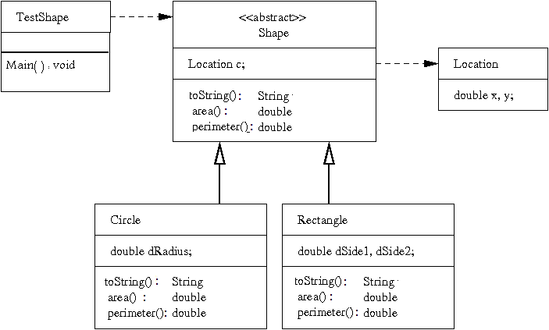

**Question 3: [8 Marks]**

Study the following class, and then answer the questions below:

using System;

using System.Collections.Generic;

using System.Linq;

using System.Text;

class Animal

{

protected double weight;

protected double height;

protected int x_coordiantion;

protected int y_coordination;

public animal(double h, double w)

{

x_coordiantion=0;

y_coordination=0;

weight=w;

height=h;

}

public abstract void talk()

{

Console.WriteLine("print from the super class");

}

public void walk(double x, double y)

{

x_coordiantion=x;

y_coordianion =y;

}

}

class cat:Animal

{

private string name;

public cat(double h, double w) : base()

{

name="Putchi";

}

public void talk()

{

return stirng.format("{0}", "meaw");

}

public void drink_milk()

{

Console.WriteLine("iam drinking milk");

}

}

class test

{

Animal a = new cat();

cat c = new cat();

c.talk();

c.walk();

a.talk();

a.walk();

a.drink_milk();

}

The three classes above have some errors . find these erorrs and correct them. **[8 marks]**

***III. Unfamiliar Problems Solving***

Objectives: *The aim of the question is to evaluate your knowledge of the key aspects of the lectures material and your ability to solve unfamiliar problems.*

**Question 4**: **[7 Marks]**

Extend the class **TestShape** in Question 2, by defining a List of type Shape.

* + Create a Method within the same class (**TestShape**) that adds a Shape into the List.
  + Create a Method within the same class (**TestShape**) that deletes a Shape in a given location ( index)
  + Use these newly defend methods in the Main method

Good Luck ☺